**CREATE A DATABASE IN CLOUDANT DB**

|  |  |
| --- | --- |
| **TEAM ID** | PNT2022TMID16047 |
| **PROJECT NAME** | Hazardous area monitoring for industrial plant powered by IOT |

**STEPS:**

1. Create an IBM Cloud and login to the account

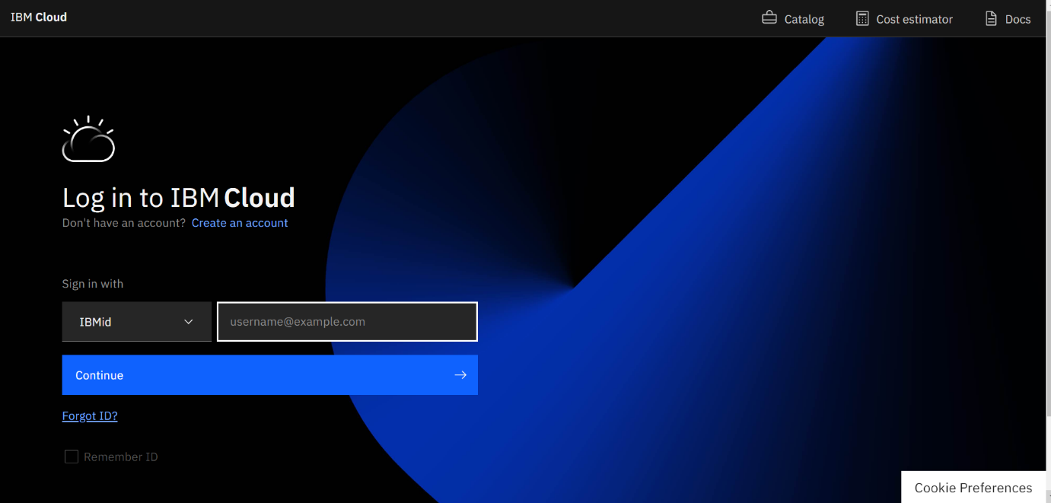

1. Dashboard of the IBM cloud will appear

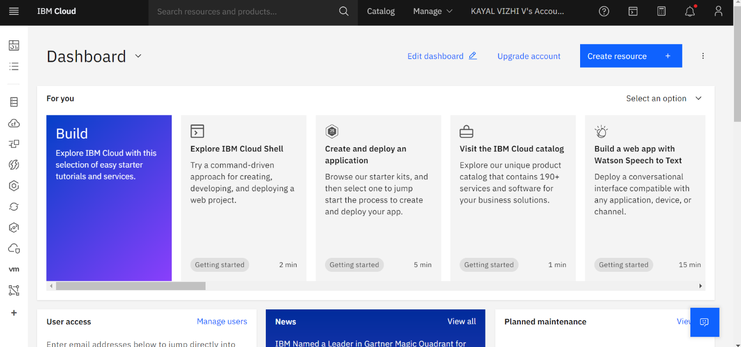

1. Click on the catalog and search for the cloudant

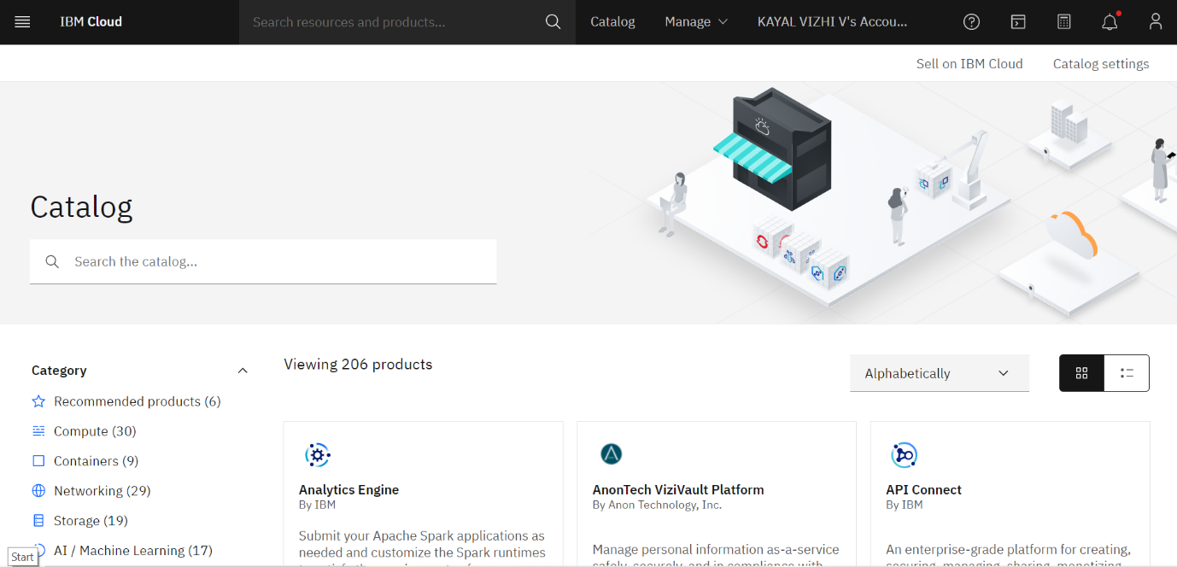

1. Click on the create

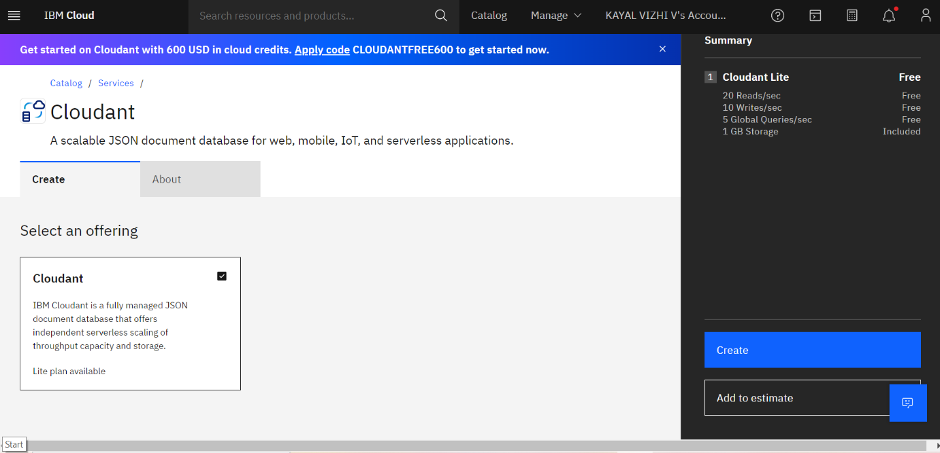

1. Navigate to the cloudant page and click the launch dashboard

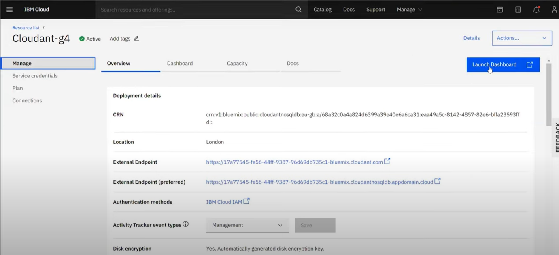

1. Launch dashboard appears

